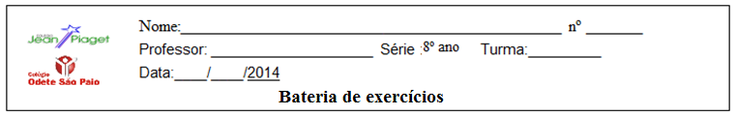

1) Use a question tag adequada:

a) You haven’t seen her today, ________________?
b) He’ll meet us there, _________________?
c) You slept at your parents’ house last night, _________________?
d)He couldn’t stay here, _________________?
e) I wouldn’t have worked there if it weren’t for you, _________________?
f) There was something bugging you, _________________?
g) I’m going there, _________________?
h) Turn up the heat, _________________?
i) It’s a cute dog, _________________?
j) She can’t sing in public, _________________?

2) Leia o texo:
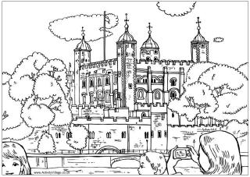
My name is Mary and I am not writing from washington, i am writing from londom now, it is a beautiful morning and the sun is shining, it is not raining now. It is half past eleven and i am standing in front of buckinghan palace, the queen's home in london. There are a lot of tourists here, from all over the world. We are watching the great show. They guard. The band is playing and the soldiers are marching. I am taking a picture.

3) Responda:
a) De acordo com o texto aonde está Mary ?
R: ___________________________________________________
b) Qual é o grande show que ela está assistindo?
R: ____________________________________________________
4) Marque um X na resposta certa:
a) De acordo com Mary o sol está:
( ) Brilhando ( ) Entre nuvens
( ) Muito forte ( ) Fraco
b) A que horas ela estava em frente ao palácio de Buckinghan?
( ) 7:00 ( ) 11:30
( ) 13:30 ( ) 8:00

5) Marque os degrees of comparasion que se encaixa perfeitamente nas frases abaixo
She’s surely the ____________ girl in town.
a)prettier
b)prettiests
c)prettiest
d)prettiere
e)most pretty

Today the weather is ______________ than yesterday.
a)the worst
b)worse
c)more had
d)baddest
e)bedest

This book is ______________ the last one we used.
a)gooder than
b)best than
c) more good than
d)worse than
e)worst than

Papyrus was used ____________ than paper.
a)more early
b)earlyer
c)earlier
d)earliest
e)early
Have you heard about the _________ news?
a)more last
b)latest
c)most often
d)laterest
e)lasted

The ____________ we study, the __________.
a)less – worst
b)less – worse
c)more – worst
d)most – best
e)least – best

6) Leia o texto e responda:

ONLY HUMAN

During a bull session about human nature, a friend made this observation: “When we Americans make sandwiches, we begin with square bread, round meat, rectangular pickles, slices of tomatoes, chopped onions and flat lettuce. We then cut the sandwiches diagonally and get angry when pieces of them fall on the floor”.
a) O plural das palavras foot, man, mouse, tooth, woman é:
( ) Foots, men, mice, teeth, womans
( ) Feet, men, mice, teeth,women
( ) Feet, man, mouses, tooths, women
( ) Feet, mans, mice, teeth, womens
b) Marque a opção correta sobre o texto:
( ) As palavras: sandwiches, slices, tomatoes, onions, pieces estão no singular.
( ) Os sandwiches são cortados em 5 pedaços.
( ) Os tomates e as alfaces são retangulares.
( ) As palavras: sandwiches, slices, tomatoes, onions, pieces estão no plural.
c) Quem fica nervoso quando pedaços do sanduíche caem no chão?
( ) Um amigo ( ) O Justin Bieber ( ) Os Americanos ( ) Os Brasileiros

7) Leia o texto a seguir:
That`s my job
This is a story about four people: Everybody, Somebody, Anybody and Nobody. There was an important job to be done and Everybody was sure that Somebody would do it. Anybody could have done it, but Nobody did. Somebody got angry about that because it was Everybody`s job. Everybody thought Anybody could do it, but Nobody realized that Everybody wouldn`t do it. It ended up that Everybody blamed Somebody when Nobody did what Anybody could have done.

8) According to the text above you`ve just read, who in fact, performed the job was:

a) Everybody
b) Nobody
c) Anybody
d) Somebody

9) Fill in the blanks with: something, someone, somewhere or anything, anyone, anywhere into the gaps.

Example: I need _________ to drink.

Answer: I need something to drink.

a) I’ve got __________ in my eye.
b) There is __________ at the door.
c) We haven’t heard __________ about Peter. Is he ill?
d) Do you live __________ near Mandy?
e) __________ wants to see you.

10) Leia o texto e marque a alternativa correta:
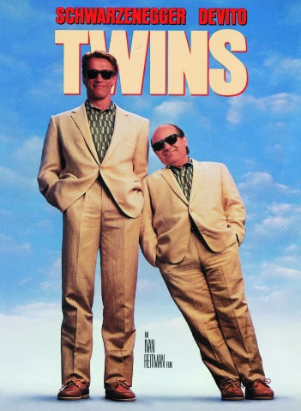
Arnold Schwarzenegger is a tall man. He’s taller than Danny De Vito. Danny is a short man. He’s shorter tan Arnold. Arnold is younger than Danny. Danny is older than Arnold
No texto, as palavras destacadas estão:
a) ( ) intimidando os dois atores.
b) ( ) comparando os dois atores.
c) ( ) descrevendo os dois atores.
d) ( ) anunciando o filme.

11) Leia o texto e responda:

Mr. Cruise was born in York, England, in 1942. He was in South Africa from 1945 to 1950 and was in the United States in 1969. He was in Germany in 1989, and after the Indian Ocean tsunami in 2004 Mr. Cruise was in Indonesia for months with the rescue team. He also was in Mexico in the World Cup in 1970. Tattoo boy is his grandson and loves to hear his stories. Tattoo boy asks his grandfather: What about the 1992 Olympic Games in Barcelona? Were you there? Mr. Cruise answers to him: No, I wasn’t. You were born in 1992, and I was there with you! Oh! Grandpa, you’re incredible! – talked Tattoo boy.
Onde Mr. Cruise nasceu?
a) ( )Na Inglaterra b) ( ) No Brasil c) ( )Na Alemanha d) ( ) Na Indonésia

12) Quando ele nasceu?
a) ( ) Em 1942 b) ( ) Em 1945 c) ( ) Em 2004 d) ( ) Em 1992

13) Onde ele estava entre 1945 e 1950?
a) ( ) Na Indonésia b) ( ) Na África c) ( ) No Brasil d) ( )No México

14) O que aconteceu em 2004?
a) ( ) Um vendaval b) ( ) Uma enchente c) ( ) Um acidente d) ( ) Um tsunami.

15) Com quem Mr. Cruise ficou na Indonésia?
a) ( )Com seus pais b) ( ) Com a equipe de resgate c) ( ) Com seu neto

16) Reescreva as sentenças a seguir usando o comparativo de inferioridade.

a) I'm not as intelligent as her.
R:________________________________________________

b) She's not as old as Bart.
R:________________________________________________

c) Brazil isn't as rich as Germany.
R:_________________________________________________

17) Traduza as frases a seguir para o português.
a) They are less beautiful than the Brazilians.
R:_____________________________________________
b) History is less difficult than Math.
R:______________________________________________

18) Como se diz "Futebol é menos chato do que basquete" em inglês?
R: ______________________________________________________

19) Passe a frase abaixo para a forma NEGATIVA:
She is as intelligent as I thought.
_____________________________________________________.
20) Passe a frase abaixo para a forma INTERROGATIVA:
I am as tall as you.
______________________________________________________?

