


“Sem limite para crescer”
Nome: _______________________________________________ nº __________

Professor(a): ______________________________ Série: 2ª Turma: __________

Data: _____/_____/2014 Desconto Ortográfico: _________
2º Trimestre

BATERIA DE EXERCÍCIOS DE INGLÊS

1) Read the love sayings.



What is a common element of love in both sayings?
A) Love is unpredictable.
B) Love is sacred.
C) Love is fragile.
D) Love is infinite.
E) Love is changeable.

Read the text and answer the questions 2, 3, and 4.

New leukemia treatment exceeds 'wildest expectations'
A single shot could be one of the biggest advances in cancer research in decades, scientists say.
By Robert Bazell Chief science and health correspondent NBC News

Doctors have treated only three leukemia patients, but the sensational results from a single shot could be one of the most significant advances in cancer research in decades. In the research published Wednesday, doctors at the University of Pennsylvania say the treatment made the most common type of leukemia completely disappear in two of the patients and reduced it by 70 percent in the third. In each of the patients as much as five pounds of cancerous tissue completely melted away in a few weeks, and a year later it is still gone. The results of the preliminary test “exceeded our wildest expectations,” says immunologist Dr. Carl June, a member of the Abramson Cancer Center's research team.
Dr. Edgar Engleman, a cancer immunologist at Stanford University School of Medicine who was not involved in the research calls the results “remarkable ... great stuff.”
The Penn scientists targeted chroniclymphocytic leukemia (CLL), the most common type of the blood disease. It strikes some 15,000 people in the United States, mostly adults, and kills 4,300 every year. Chemotherapy and radiation can hold this form of leukemia at bay for years, but until now the only cure has been a bone marrow transplant. A bone marrow transplant requires a suitable match, works only about half the time, and often brings on severe, life-threatening side effects such as pain and infection.

Glossary:
shot: injeção
strikes: acomete
hold at bay: neutralizar, manter a distância
bone marrow: medula óssea
2) The new leukemia treatment
A) is the result of a more than ten-year research.
B) was carried out by Dr. Edgar Engleman.
C) succeeded with two of the patients researched.
D) can cure most types of blood disease.
E) is already available to 15,000 thousand Americans.

3) What does the new treatment depend on?
A) Chemotherapy.
B) A single shot.
C) Radiation.
D) A bone marrow transplant.
E) A suitable match.

4) The following phrases refer to the research on the new leukemia treatment except for
A) “life-threatening side effects”.
B) “biggest advances”.
C) “sensational results”.
D) “remarkable stuff”.
E) “wildest expectations”.

5) Fill in the blanks with the correct form of the following modals:
can, could, be able to, may, might, shall, should, must, have to, don’t have to, need to
– You may have to make the modals negative according to the context of the sentence.
– There may be more than one possibility.
He has to take his car to be serviced. The brakes are squeaking.
Would you please save me a seat at the dinner event.

A) If you are sick, you ________ go to work. You’ll infect everyone there.
B) Drivers _______ stop at red lights.
C) You _______ finish the proposal today. You can finish it tomorrow.
D) She ______ hear much better with her new hearing aids.
E) ______ I order us a bottle of wine?
F) Sam ______ pick his daughter up from school. She’s taking the bus home.
G) You _____________ smoke here. It’s a smoke-free building.

6) Choose the correct answer:

A. My lesson starts _______ five o’clock.
a) on b) at c) in
B. My father usually buys a newspaper ___________ the morning.
a) on b) at c) in
C. We wear warm clothes _________ winter.
a) on b) at c) in
D. We get presents ________ Christmas.
a) on b) at c) in
E. I usually visit my grandparents __________ Sunday afternoon.
a) on b) at c) in
F. John’s birthday is __________ August 16th.
a) on b) at c) in
G. The film finishes ___________ 9:30.
a) on b) at c) in
H. The supermarket is closed __________ Sunday.
a) on b) at c) in
Leia o excerto sobre estereótipos e responda às questões 7 e 8.
Civil societies can only thrive when damaging stereotypes are broken down. The difficulty is that stereotypes are sometimes hard to recognize because they are fixed beliefs. Learning to identify stereotypes is one of the first steps we must take to build a civil society. All of us face peer pressure when confronted with a joke which puts down a certain minority. It takes courage to raise objections to these jokes and pejorative names and to actively fight the prejudice and bigotry which they foster. It is important to stand up against injustice, and fight the discrimination, stereotypes, and scapegoating which have served as the precursors to persecution, violence, and genocide. After identifying stereotypes, we can work toward eliminating them from society. When stereotypes are eliminated, it will be easier to acknowledge and appreciate individual differences. When we live in a society that is open to cultural diversity and that values the contributions of all society members – regardless of cultural and ethnic backgrounds, race, life styles, and belief – we will be one step closer to living in a civil society.

Vocabulário:

puts down: deprecia
bigotry: intolerância
stand up against: lutar contra
scapegoating: acusações injustas

7) Segundo o texto, as sociedades civis só podem prosperar se os estereótipos nocivos forem eliminados. O que impede que isso aconteça deve-se ao fato de que os estereótipos
(A) são crenças estabilizadas e difíceis de ser reconhecidas.
(B) se confundem com as piadas e frases preconceituosas.
(C) são uma forma de manter as minorias em posição inferiorizada.
(D) não são vistos negativamente como, por exemplo, o genocídio.
(E) são percebidos como evidência de diversidade cultural.

8) No texto, afirma-se que “é preciso coragem para se opor a essas piadas [...]”. Você estaria se opondo a uma piada se dissesse:
(A) “That's a real good one!”
(B) “Am I supposed to laugh?”
(C) “I'll tell you a better one.”
(D) “I'll write that down.”
(E) “It's the best I've ever heard.”

9) Retire do texto dois exemplos de Modal Verbs:
_________________________________________________________________________________________

10) Retire do texto duas preposições:
_________________________________________________________________________________________

Concerning national stereotypes, answer questions 11 and 12.

11) Which of the following opinions is in favour of national stereotypes?
(A) “National stereotypes are dangerous because they may provoke racial prejudice.”
(B) “National stereotypes are predictions based on incomplete information about their culture, race, religion, or
ethnicity.”
(C) “National stereotypes are misleading and reduce nationalities to a rigid, inflexible image.”
(D) “National stereotypes are harmless sorts of jokes we tell about other nationalities or groups of people.”
(E) “National stereotypes are a form of blind categorization that leads to false assumptions about peoples.”

12) National stereotypes are almost always negative. An example of a positive stereotype is found in:
(A) Chinese do not respect laws and talk loud regardless where they are.
(B) Mexicans drink too much tequila and work for little money.
(C) Italian men are hot-blooded and/or over-emotional, and live an indulgent life style.
(D) North Americans are war-mongering and do not know about other countries.
(E) English tolerate eccentric people, drink tea, and are football enthusiasts.

Leia o texto introdutório e os dois cartuns. As questões 13 e 14 referem-se a eles.
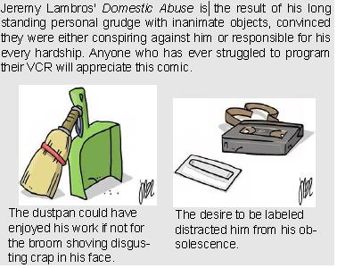

Vocabulário:
grudge: ressentimento
hardship: sofrimento
shoving: empurrando
labelled: etiquetado

13) O objetivo principal do texto introdutório é explicar a razão pela qual
(A) Lambros cria com base em objetos.
(B) os objetos conspiram contra o autor.
(C) o leitor deve observar os objetos à sua volta.
(D) os objetos fazem o autor sofrer.
(E) Lambros aprecia cartuns sobre objetos.

14) Os cartuns têm em comum o fato de os objetos personificados serem
(A) colocados em uma relação de tensão entre si.
(B) revoltados com sua condição inanimada.
(C) mostrados como conscientes de seus direitos.
(D) afetados por conflitos interiores.
(E) felizes com as funções que desempenham.

TEXTO REFERENTE ÀS QUESTÕES DE 15 A 19.
DOWN TO THE DEEP
Humans have visited the very bottom of the ocean only a few times. The first expeditions took place in 1960, when Jacques Piccard set the U.S. Navy submersible Trieste down; the next occurred thirty five years later, when Japan’s Kaiko, a multimillion dollar remotely operated vehicle (ROV), returned briefly to that black realm during several dives. The extreme depths and pressures of the earth’s least explored territories have kept scientists from studying the ocean’s abyss up so close. Engineers at Woods Hole Oceanographic Institution, Johns Hopkins University and the U.S.
Navy have begun developing an undersea craft that is designed to do meaningful science at the lowest depths routinely and cost-effectively. The device will be a hybrid ROV, it will combine the capabilities of a fully autonomous undersea robot with those of a craft piloted from the surface via a thin optical-communications fiber, the same technology used to guide torpedoes. The system is intended to be compact, lightweight and easily deployed from standard oceanographic vessels. If it all goes well, the hybrid ROV will let scientists better understand fundamental processes occurring at the deep subduction zones along the continental margins. Further, it will permit the exploration of the unknown seas below the polar ice packs as well as the study of any new undersea phenomenon that emerges unexpectedly.
(Adapted from SCIENTIFIC AMERICAN, Dec. 2003, p.17)
15) The Kaiko’s expedition took place in _____.
A) 1035
B) 1925
C) 1995
D) 1935
E) 1960
16) Kaiko returned to the bottom of the ocean:
A) never
B) hardly ever
C) once
D) frequently
E) not many times

17) Kept from in ‘...kept scientists from studying...’ means:
A) induced
B) prevented
C) made
D) disturbed
E) maintained

18) As well as in ‘...as well as the study of any new...’ can be best replaced by:
A) and
B) very good
C) too
D) best
E) very well

19) According to the text:

I) Men have visited the very bottom of the
sea several times.
II) Trieste was a U.S. Navy aircraft.
III) The hybrid ROV is intended to do science
cost-effectively.
IV) Scientists are sure that the hybrid ROV will be successful.
A) T – T – F – T
B) F – T – T – F
C) T – F – F – T
D) F – F – T – F
E) T – F – T – F

Leia a tirinha a seguir e respondas às próximas questões:

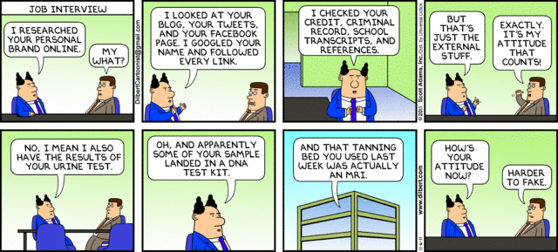

20) No contexto em que se insere, “external stuff”, no quarto quadro da tirinha, foi interpretado, pelo entrevistado, como
A) funcionários terceirizados
B) exames de rotina para contratação
C) Informações de menos importância
D) dados de veracidade questionável
E) dados investigados externamente
21) Segundo a tirinha, em uma entrevista de trabalho
A) está cada vez mais difícil falsear informações pessoais
B) a empresa contratante exige uma série de exames clínicos que atestem a saúde do candidato
C) a atitude do candidato é comprovada através de detalhada investigação laboratorial
D) o desempenho do entrevistado é de suma importância para a construção de sua imagem
E) as informações sobre o entrevistado, disponíveis online, não são mais importantes do que sua atitude e apresentação pessoal

22) A palavra “landed” na sentença “apparently some of your sample landed [...]”, no sexto quadro da tirinha, pode ser substituída por
A) stopped
B) ended up
C) was included
D) arrived
E) was caught

23) Use the correct question tags:
a) ...it is correct to say… ,___________________?
b) …many writers would write about fantasy and also about true stories…, ___________________?
c) They read for information at that time..., ___________________?
d) Read it out loud, ___________________?
e) Let’s read about American Literature, ___________________?

As questões de 24 a 30 referem-se ao texto a seguir:

Reboot the School
SALMAN KHAN’S YOUTUBE LESSONS HAVE ALREADY MADE HIM A GEEK CELEBRITY.
NOW HE WANTS TO REINVENT HOMEWORK, BANISH CLASSROOM LECTURES—AND MAYBE SAVE EDUCATION.
By Kayla Webley
Fifth-graders at Eastside College Preparatory School in East Palo Alto, Calif., sit at their desks with netbooks. They're in the middle of a math lesson, listening as a teacher explains how to convert percentages to decimals. "If we get rid of the percent sign, we just have to move the decimal sign two places to the left," the instructor says. Pens scribble across notebooks. Eleven thousand miles away in Accra, Ghana, students at the African School for Excellence are studying logarithms. Their teacher is the same one firing off math tips in California–both groups of kids are learning by watching online videos. While the screen shows a march of equations and diagrams, the students never actually see the face of the lecturer. There's just a voice, deep, patient and unrehearsed—think NPR host crossed with Mister Rogers. His inflection rises at times to underscore a point or when he gets really excited. "Math is not just random things to memorize and regurgitate on a test next week," he says. "It's the purest way of describing the universe!"
The voice belongs to Salman Khan, a 35-year-old hedge-fund manager turned YouTube professor to millions around the world. Thanks to his Khan Academy, an online repository of some 3,250 digital lectures, he has become a celebrity to techies, educators and uncounted high schoolers cramming for the AP biology test. His 18-minute discourse on the Krebs cycle and cell metabolism has been viewed more than 675,000 times. But Khan isn't satisfied with being the most famous teacher ever to appear on a Web browser. He believes he has stumbled onto a solution to some of education's most intractable problems, with his video-driven teaching method at its heart. He wants to fundamentally change the role of teachers in the classroom—and redefine the concept of homework along the way. And he has persuaded Bill Gates, Google's Eric Schmidt and a minor constellation of other tech billionaires to back this quest. Education reform is notoriously difficult. K-12 schools are debating everything from teacher evaluations to standardized tests, with no consensus in sight. Universities, meanwhile, are confronting massive budget cuts and new kinds of competition—as dramatized by the recent turmoil at the University of Virginia. Its board fired the president amid worries that UVa wasn't keeping up with change and embracing online education fast enough, then rehired her 16 days later after a backlash from students and faculty. At all levels, there's plenty of skepticism about any tech-centric approach to teaching. An estimated $65.7 billion was spent in the U.S. last year on education technology, according to research firm Gartner. But many educators say there is little concrete proof of its benefits.
Khan is already butting up against veteran teachers nervous about their roles in his brave new classroom. But the biggest obstacle of all may be Khan himself. For all his grassroots fandom and Silicon Valley cred, he's not an educator, and he's never worked with children. Are parents and teachers ready to upend hundreds of years of precedent about how basic subjects are taught on the word of a guy who has spent more time analyzing financial statements than standing before a blackboard?
Fonte: Time, July 9, 2012. Texto adaptado
24. Escolha a opção correta.
A O texto descreve o método adotado para o ensino de matemática na Eastside College Preparatory School, em Palo Alto, Califórnia.
B O uso da tecnologia está tão disseminado que em Gana, África, substitui o professor no ensino de logaritmos.
C Khan não é educador, mas pode ter encontrado a solução para alguns problemas educacionais.
D Cortes no orçamento provocaram demissão em massa e tumulto na Universidade de Virgínia.
E Nos vídeos online, não é possível ver o rosto do professor; apenas se ouve a voz de Mister Rogers.

25. Na sentença em que se insere “He believes he has stumbled onto a solution to some of education’s most intractable problems” (linhas 18 e 19), o verbo “stumbled onto” pode ser substituído por
A come upon.
B search for.
C figured out.
D come up with.
E pointed out.

26. A palavra “teaching”, em “video-driven teaching method” (linha 19),
A deve ser traduzida por “ensinando”.
B tem a mesma função gramatical da palavra “YouTube”, na construção “YouTube professor” (linhas 12 e 13).
C refere-se à palavra “video”.
D tem a mesma função gramatical da palavra “professor”, na construção “YouTube professor” (linhas 12 e 13).
E tem a mesma função gramatical da palavra “turned”, na construção “turned YouTube professor” (linhas 12 e 13).

27. No contexto em que se insere, “this quest” (linha 22) refere-se
A à tentativa de disseminação do uso de tecnologia na educação formal.
B à busca de aprovação de bilionários da tecnologia para sua pretensão de introduzir educação online no sistema de ensino.
C ao questionamento acerca das abordagens do ensino tradicional.
D à tentativa de desenvolver tarefas de casa de forma que cada estudante trabalhe no seu próprio ritmo.
E à busca por mudança no conceito de ensinar e de fixar o conteúdo ensinado.

28. Nas frases “Their teacher is the same one firing off math tips in California […]” (linha 6) e “Its board fired the president amid worries […]” (linha 26)
A “firing off” e “fired”, embora utilizados em tempos verbais diferentes, têm o mesmo significado.
B “firing off” equivale a sending quickly.
C “firing off” e “fired” têm sentidos opostos.
D “firing off” e “fired” podem ser substituídos, respectivamente, por shooting off e shot.
E “firing off” equivale a spread e “fired” equivale a detonate.

29. Assinale a opção correta, de acordo com o texto.
A Professores, de modo geral, acreditam que o ensino centrado numa abordagem tecnológica pode ser a grande promessa para o avanço educacional.
B Khan quer contar com a ajuda de celebridades como Bill Gates para vencer algumas resistências em relação ao seu método educacional.
C Há pais e professores que desconfiam da pretensão de um profissional do mercado financeiro em substituir a experiência educacional acumulada ao longo de muito tempo.
D Há descrença quanto à aplicação da abordagem de Khan em crianças do ensino fundamental.
E A maioria dos professores do ensino regular defende uma proposta de ensino tradicional.
30. A palavra “actually” (linha 8)
A está empregada com o mesmo significado de can.
B é um cognato.
C está relacionada à modernidade mencionada no texto.
D é sinônimo de eventually.
E equivale a really.

TEXT
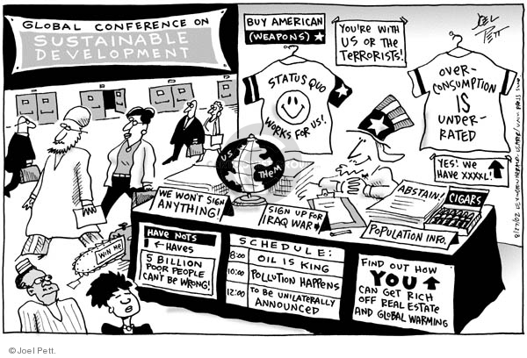

31. What are the themes of Rio+20 that can be criticized at this cartoon?
(A) Environment preservation and economic development, agreements and protocols.
(B) Eradication of poverty and Iraq war.
(C) Carbon footprint, Ozone layer and U.S. election.
(D) Efficient use of natural resources and division of the world into two main blocks.

32. Why is this cartoon funny?
(A) Because the items presented in the stand are against the things discussed at the conference.
(B) Because the old man is characterized and Uncle Sam, from United States and he is really funny.
(C) Because the character is selling stuff at the conference, but it is forbidden.
(D) Because that is exactly what people see and discuss at this kind of conference.

Read:
WE ARE ALL HOUSEKEEPERS!
Plant a tree... use recycled paper... don’t waste fuel... save water... keep your engine well adjusted... walk... don’t smoke... don’t wear fur... use biodegradable products. In this way we’ll keep our house in order.
Time, September 28, 1992

33. De acordo com o texto, nosso planeta está sendo comparado a um objeto. Qual? Porque essa comparação foi feita?
__________________________________________________________________________________________________________________________________________________________________________________

(UFGM) As questões abaixo se referem ao texto seguinte:
One day something happened which in a roundabout way was enlightening. It was a tiny incident in itself, but it gave me a better glimpse than I had had before of the real nature of imperialism – the real motives for which despotic governments act. Early one morning the sub inspector as a police station the other end of the town rang me up on the phone and said that an elephant was ravaging the bazaar. Would I please come and do something about it? I did not know what I could do, but I wanted to see what was happening and I got onto a pony and started out. I took my rifle, an old 44 Winchester and much too small to kill an elephant, but I thought the noise might be useful in terrorem.
Various Burmans stopped me on the way and told me about the elephant’s doings. It was not, of course, a wild elephant, but a tame one which had gone “must”. I had been chained up, as tame elephants always are when their attack of “must” is due, but on the previous night it had broken its chain and escaped. Its mahout, the only person who could manage it when it was in that state, had set out in pursuit, but had taken the wrong direction and was now twenty hours journey away, and in the morning the elephant had suddenly reappeared in the town. The Burmese population had no weapons and was quite helpless against it. It had always destroyed somebody’s bamboo hut, killed a cow, and raided some fruit stalls and devoured the stock; also it had met the municipal rubbish van and, when the driver jumped out and took to his heels, had turned the van over and inflicted violence upon it.

Answer the following questions according to the passage above.

34. What was usually done when an elephant went “must”?
_________________________________________________________________________________________

35. Why was the Burmese population helpless against the elephant?
__________________________________________________________________________________________________________________________________________________________________________________

36. Change the sentences below into the passive voice.

a) The mahout has taken the wrong direction.
_________________________________________________________________________________________

b) People will not put crazy elephants in cages.
_________________________________________________________________________________________

c) They were waiting for me outside the village.
_________________________________________________________________________________________

(UENF) SCIENCE – Man-made chemicals are destroying the ozone layer, but so are natural ones. The 1991 Mount Pinatubo eruption released ozone-unfriendly chlorine compounds: researchers believe they were partly responsible for the record ozone hole that opened up over Antarctica last year.

Responda em Português às questões 37 e 38, de acordo com informações do texto acima.

37- O texto afirma que há dois fatores responsáveis pela destruição da camada de ozônio. Os produtos químicos produzidos pelo homem são um deles. Qual é o outro?
__________________________________________________________________________________________________________________________________________________________________________________

38- Durante a erupção do Monte Pinatubo, houve a liberação de compostos clorados. Que consequência isso teve para a camada de ozônio?
_________________________________________________________________________________________

Mark the correct alternative:

39- (OBJ-SP) Assinale a alternativa que corresponde à voz passiva de: “The invention of the automobile has changed American life in many ways.”
a) American life is being changed in many ways.
b) American life was being changed in many ways.
c) American life is changed in many ways.
d) American life has been changed in many ways.
e) American life would be changed in many ways.

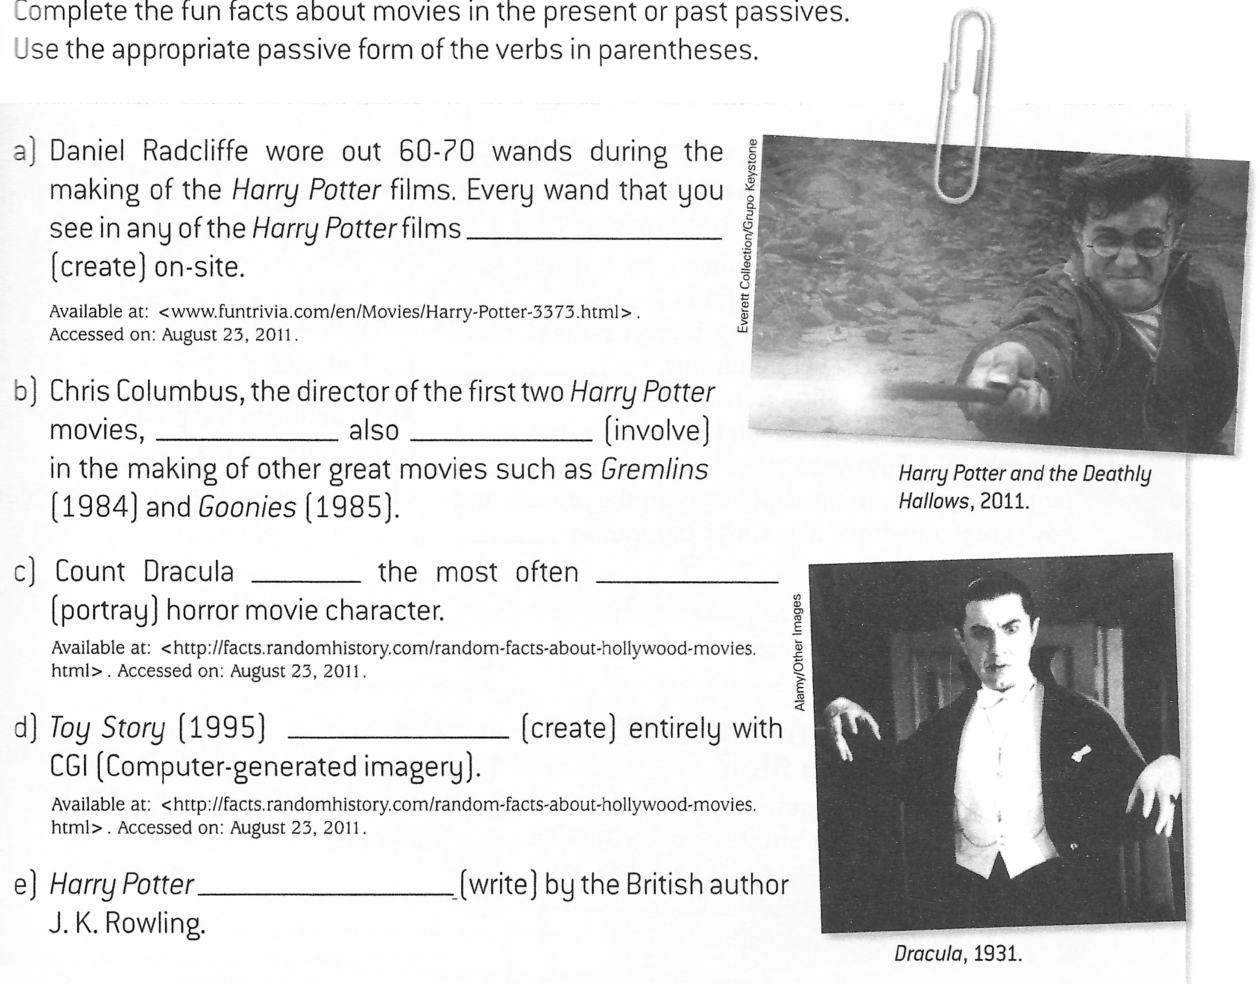
40- Complete the fun facts about movies in the present or past passives Use the appropriate passive form of the verbs in parentheses.

Leia o texto Introducing E-jets, produzido para um folheto de propaganda dos aviões da Embraer.

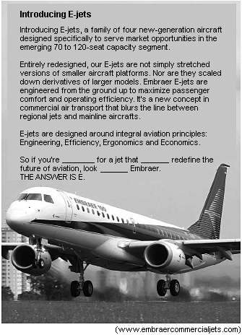

41. (Unesp 2010) Assinale a alternativa cujas palavras podem ser utilizadas para completar os espaços no último parágrafo do texto:
a) looked ... will ... for
b) flying ... can ... for
c) flown ... will ... at
d) flying ... can ... at
e) looking ... will ... to

42. Choose the incorrect use of either...or, neither...nor:
a) Neither Mike nor Lisa won't be there.
b) You can either help us or go to your room.
c) He speaks neither English nor French.
d) I will neither help you nor go to my room.
e) We brought neither coffee nor tea.

43. Choose the correct use of connectives:
a) He does not have a pen. He does not have paper. He has neither a pen nor paper.
b) Ron enjoys horseback riding. Bob enjoys horseback riding. Both Ron and Bob enjoys horseback riding.
c) You can have tea, or you can have coffee. You can have either tea or coffee.
d) Arthur is not in class today. Ricardo is not in class today. Both Arthur and Ricardo are not in class today.
e) Arthur is absent. Ricardo is absent. Neither Arthur or Ricardo is absent.

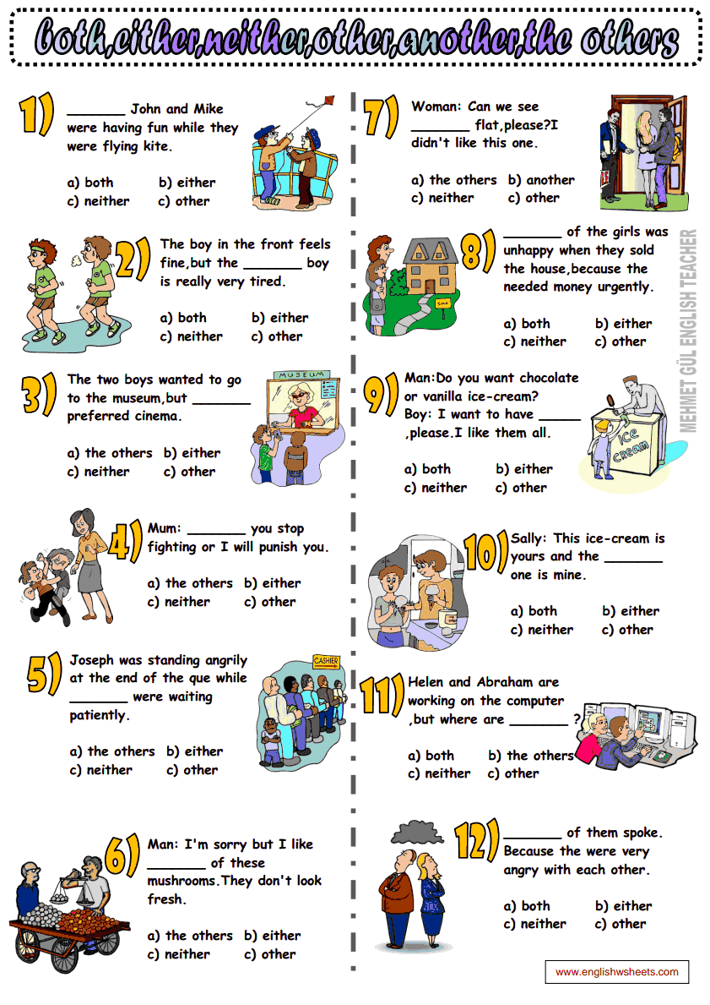
44. Complete the sentence: "_______ John and Mike were having fun while they were flying kite."

a) both
b) either
c) neither
d) other
e) nor

45. Choose the best option:
a) If I move, I live on Main Street.
b) If you’ll call your mother, she’ll be very happy.
c) If the mechanic fixes our car on time, we drive to Center Ville.
d) If it rains today, we won’t go to the park.
e) If I’m not in a hurry tonight, I wrote to her.

FROM JESUS TO CHRIST

How did a Jewish prophet come to be seen as the Christian savior? The epic story of the empty tomb, the early battles and the making of a great faith.
By Jon Meacham

The story, it seemed, was over. Convicted of sedition, condemned to death by crucifixion, nailed to a cross on a hill called Golgotha, Jesus of Nazareth had endured all that he could.
According to Mark, the earliest Gospel, Jesus, suffering and approaching the end, repeated a verse of the 22nd Psalm, a passage familiar to first-century Jewish ears: my God, my God, why have you forsaken me?. There was a final, wordless cry. And then silence.
From the Gospel accounts, it was a question for which Jesus´ s disciples had no ready answer. In the chaos of the arrest and Crucifixion, the early followers had scattered. They had expected victory, not defeat, in this Jerusalem spring. If Jesus were, as they believed, the Jewish Messiah, than his great achievement would be the inauguration of the Kingdom of God on earth, an age marked by the elimination of evil, the dispensation of justice, the restoration of Israel and the general resurrection of the dead. Instead, in the Friday of this Passover, at just the moment they were looking for the arrival of a king of heaven on earth, Jesus, far from leading the forces of light and triumph, died a criminal´s death (.)

46- A frase “..it was a question for which Jesus’ disciples had no ready answer.” permanece com o mesmo significado em:
a) it was a question whose answer Jesus’ disciples did not have.
b) it was a question that Jesus’ disciples had no ready answer.
c) it was a question that Jesus’ disciples answered.
d) it was a question whom Jesus’ disciples had no answer.
e) it was a question for that Jesus’ disciples had no ready answer.

47- As expressões “pregado na cruz”, “eliminação do mal” e “ressurreição dos mortos” estão presentes no texto em:
a) death by crucifixion; wordless cry; dispensation of justice.
b) nailed to a cross; elimination of evil; general resurrection of the dead.
c) convicted of sedition; elimination of evil; general resurrection of the dead.
d) chaos of the arrest and Crucifixion; wordless cry; dispensation of justice.
e) condemned to death by crucifixion; elimination of evil; convicted of sedition

TEXTO PARA A PRÓXIMA QUESTÃO:

Twilight

Twilight is a 2008 American romantic vampire film based ______ Stephenie Meyer’s popular novel of the same name. It is the first film in The Twilight Saga film series. This film focuses on the development of the relationship between Bella Swan and Edward Cullen (a vampire), and the subsequent efforts of Cullen and his family to keep Swan safe ______ a coven of evil vampires.
The project was in development for approximately 3 years ______ Paramount Pictures, during which time a screen adaptation that differed significantly from the novel was written. Principal photography took 44 days and the film was primarily shot in Oregon.
Twilight was theatrically released ______ November 21 2010, grossing over US$392 million worldwide and became the most purchased DVD of the year. The soundtrack was released in the same year. Following the success of the film, New Moon and Eclipse, the next two novels in the series, were produced as films the following year.
Adapted from Wikipedia

48. (Epcar (Afa) 2012) Choose the correct prepositions to fill in the gaps above.
a) of – off – at – in
b) about – to – over – at
c) under – for – off – in
d) on – from – at – on
e) behind – over – about – in

49. (Upe 2012) Read the paragraph and fill in the blanks using a preposition.
Freddie Mercury was born ______ September 5th, 1946. He was the vocalist _____ the band rock
“Queen” and composed many hits _____ the band. As the lead _____ “Queen”, he travelled all _____ the world. Freddie Mercury died ____ 1991.
a) for; of; of; of; under; in
b) on; of; for; of; around; in
c) in; of; of; all; over; on
d) at; at; in; in; of; at
e) to; at; on; at; around; at

50. Marque a alternativa que tenha a correspondência correta entre o verbo modal da frase e o uso desse verbo.
a) Everybody would like to live in a better world. – Indica certeza.
b) Ted might get a job soon. – Probabilidade remota.
c) We shall leave work at 6 p.m. – Indica expectativa.
d) Carol must be at school now. – Dedução.
e) Could you give me the sugar? – Habilidade no passado.

